5.2 Line Integrals Worksheet

- Let C be the curve in parameterized by for .
- Evaluate the integral .

- Evaluate the integral .

- Evaluate the integral .

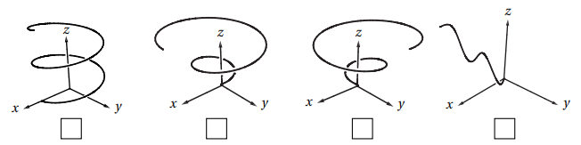
- Mark the picture of the curve in parameterized by for .
- Let C be the curve parameterized by for . Compute .

- Find the mass of a thin wire in the shape of the curve where , if the wire has density function .

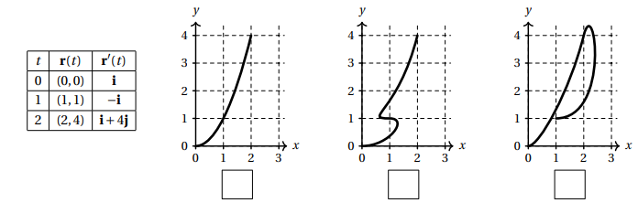
- Suppose that is a parametric curve in the plane and that and have the values given in the table at left. Check the box below the picture that could be a plot of .
- Let C be the oriented curve parameterized by where .
- Check the box next to the picture which best matches C.
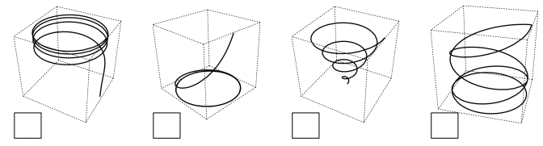

- Calculate the line integral

- Suppose a wire can be modeled by the segment of the circle from to , when moving counterclockwise. If the linear density of this wire is measured by for any point on the wire, then set up an integral which represents the mass of this wire.

- Let , and C be a curve which is the intersection of the surfaces and from to . Compute the line integral .

- Let C be the curve in parameterized by for .
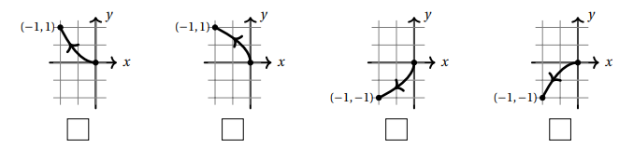
- Mark the picture of C from among the choices below.
- For the vector field compute .

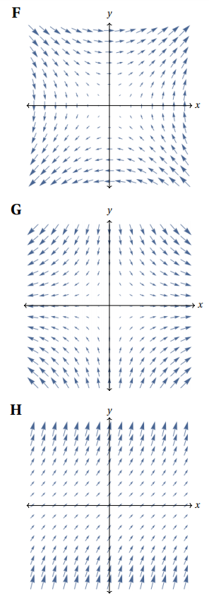
- Three continuous vector fields F,G, H on are plotted below in the region with and . Circle the best response for each of the following questions.
- Which vector field represents , where .
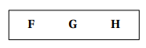

- A particle moves along a straight line from to . If the vector fields represent force fields, then:

The work done by G on the particle is…
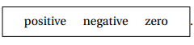

The work done by H on the particle is…


- Find , where and C is the path along the circle of radius 3 starting at the point and ending at the point while moving clockwise.

- Consider the curve C parameterized by where .
- Check the box next to the correct sketch of C.

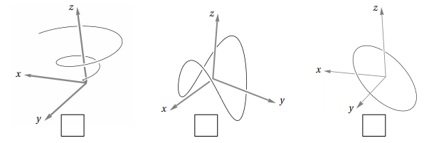

- Find the work done if a particle travels along path under the force given by the vector field .

- Let C be the helix parameterized by where .
- Let be the vector field defined by . Determine when C is oriented in the direction from to .

- Now let . Determine when C is given the opposite orientation.

